NEW PATIENT REGISTRATION & HISTORY

How did you hear about us: Website Referral, if so, whom may we thank: Other:

Patient Information
Last Name: |  |  |  | First Name: |  |  |  |  |  |  |  |  |  | Sex: M F |  |  |  | DOB:
Street Address:
City: |  |  |  |  |  |  |  |  |  |  | State: |  |  |  |  |  | Zip:
Home Phone: |  |  |  |  |  |  | Cell Phone:
Email:
Employment Information
Occupation: |  |  |  |  |  | Employer:
Employer Address:
Employer Phone:
Emergency Contact Information
Contact Name: |  |  |  |  |  |  |  |  |  |  |  | Relationship to Patient:
Phone:
Insurance Information
Subscriber Name: |  |  |  |  |  |  |  |  |  | Subscriber DOB:
Relationship to Patient: |  |  |  |  | Insurance Co:
ID #: |  |  | Group #: |  |  |  |  |  |  |  |  |  | Is patient covered by additional insurance?  Yes No
Exercise | Work Activity |  |  |  |  |  |  |  | Habits
None  Moderate  Heavy | Sitting  Standing  Light Labor  Heavy Labor |  |  |  |  |  |  |  | Smoking, Packs/Day________________________  Alcohol, Drinks/Day or Week_________________  Coffee/Caffeine Drinks, Cups/Day_____________  High Stress Level, Reason____________________
Medications & Purpose (list) |  |  |  |  | Allergies |  |  |  |  |  |  |  |  |  | Supplements
Health History (check all that apply)
AIDS/HIV  Alcoholism  Allergies (shots?)  Anemia  Anorexia  Appendicitis  Arthritis  Asthma  Bleeding disorders  Breast lump  Bronchitis  Bulimia  Cancer  Cataracts  Chemical dependency  Chicken pox |  | Chronic fatigue  COPD/Emphysema  Depression/Anxiety  Diabetes  Epilepsy  Fractures  Glaucoma  Goiter  Gout  Headaches  Heart Disease  Herpes  High blood pressure  High blood cholesterol  Hepatitis  Hernia |  |  |  |  |  | Herniated disc  Kidney Disease  Liver Disease  Measles  Miscarriage  Mononucleosis  Multiple Sclerosis  Mumps  Osteoporosis  Pacemaker  Parkinson’s Disease  Pinched nerve  Pneumonia  Polio  Prostate problems  Prosthesis |  |  |  |  |  |  |  | Psychiatric care  Rheumatic Fever  Scarlet Fever  Skin Conditions  Stroke  Suicide Attempt  Thyroid Problems  Tonsillitis  Tuberculosis  Tumors/Growths  Typhoid Fever  Ulcers  Urinary Tract Infections  Vaginal Infections  Venereal Disease  Whooping Cough  Other
Females Only: Are you pregnant? Yes No Due Date:
Do you have any skin conditions today? Skin Rash Cuts/Scrapes/Bruises Burns

List injuries/surgeries including dates and description:

Family History (check all that apply to immediate family members)
Asthma  Arthritis-Rheumatism  Back Problems  Cancer | Circulation Problems  Diabetes  Emphysema  Headaches | Heart Disease  High Blood Pressure  HIV Positive  Ulcer/Stomach Problems | Stroke  Thyroid Disease
Primary Care Physician (PCP):__________________________________________________________

Address:____________________________________________________________________________

Phone:__________________________________ Date Last Seen:______________________________

I give Kirkland Whole Life Clinic permission to contact my PCP for medical history/treatment plan: Yes No

Patient Condition
Reason for Visit and Goals:

What treatment, if any, have you received for this condition? Medical Physical Therapy Massage None
Other (please describe):
Name/address of other doctor(s) who have treated you for this condition:

Is condition due to an accident? Yes No  If yes, date: |  |  | Type of accident: Auto Work Home Other
Have you reported the accident?  Yes No | If yes, to whom? Auto Insurance Employer Worker Comp Other
Attorney Name & Phone # (if applicable)
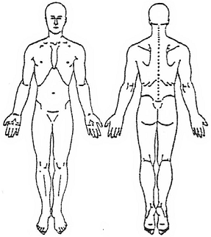 |  | How often are symptoms occurring?  daily x ___ weekly x___ monthly x___ constantly
How long does each episode last?

only as long as the activity lasts seconds minutes hours days constant

Rate severity of symptoms on graph below:

No Pain ----------------------------------------------------------- Severe Pain

 |  | List any activities that are inhibited by your symptoms:
Describe pain/symptoms as they are today: aching burning stabbing shooting sharp dull electric
tingling/prickly numbness other:____________________
Are there any questions, or other symptoms/concerns you want the practitioner to know about:

Assignment and Release: I, the undersigned, certify that I (or my dependent) have insurance coverage with above stated company/companies and assign directly to Kirkland Whole Life Clinic all insurance benefits, if any, otherwise payable to me for services rendered. I understand that I am financially responsible for all charges whether or not paid by insurance. I hereby authorize the doctor to release all information necessary to secure the payment of benefits. I authorize the use of this signature on all insurance submissions.

______________________________________ ____________________
Signature of Patient or Patient’s Representative Date
Representative’s relationship to patient: _______________________________

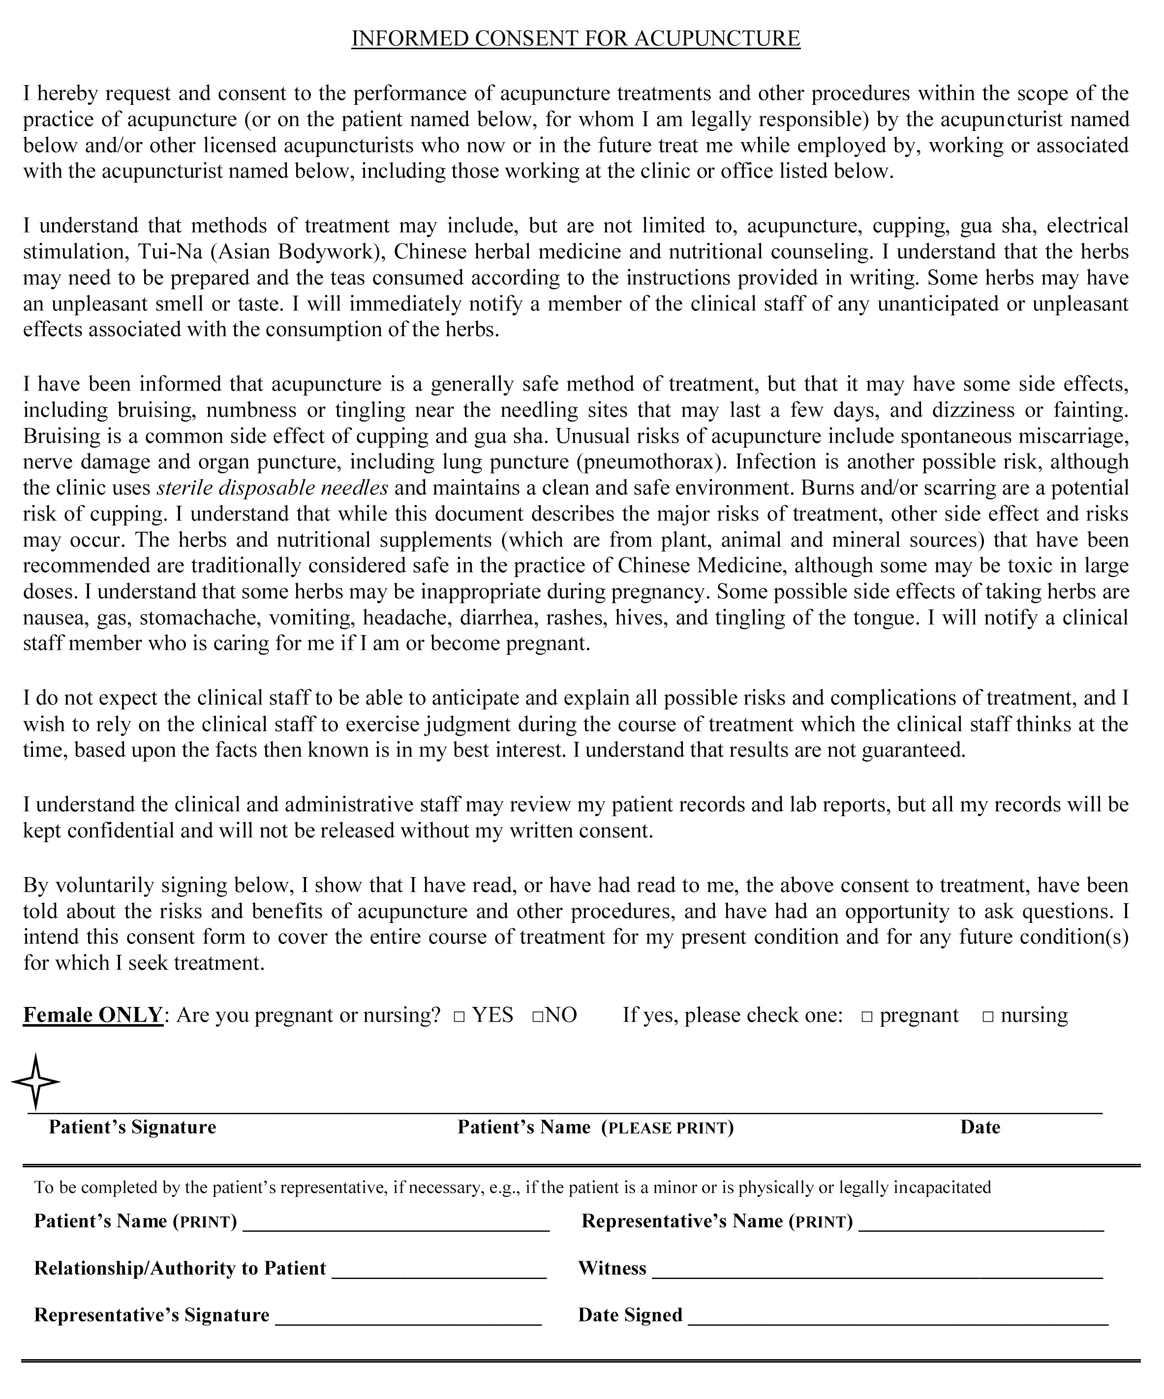

HIPAA CONSENT FORM

I understand that I have certain rights to privacy regarding my protected health information. These rights are given to me under the Health Insurance Portability and Accountability Act of 1996 (HIPAA). I understand that by signing this consent form I authorize the Kirkland Whole Life Clinic to use and disclose my protected health information for the following purposes:

- Treatment (including direct or indirect treatment by other healthcare providers involved in my treatment);
- Obtaining payment from third party payers (e.g. my insurance company); and
- Day-to-day healthcare operations of the Kirkland Whole Life Clinic such as quality assessments.
I have also been informed of and given the right to review and secure a copy of Kirkland Whole Life Clinic’s Notice of Privacy Practices, which contains a more complete description of the uses and disclosures of my protected health information and my rights under HIPAA.

____________________________________________

Patient Name (please print)

_____________________________________________

Patient/Guardian Signature

_____________________________________________

Date

Patient Notification of Dr. William Duarte’s
Qualifications & Scope of Practice

Dr. William Duarte is a licensed East Asian Medicine Practitioner (EAMP). This is the formal title for Acupuncture and Oriental Medicine practitioners in the State of Washington. East Asian medicine includes a broad range of medicine practices sharing common concepts which developed in China and are based on a tradition of more than 2,000 years, including various forms of herbal medicine, acupuncture, massage, exercise and dietary therapy. Dr. Duarte’s qualifications/certification and scope of practice follows:

1. Education and License:
- Oregon College of Oriental Medicine, Portland, Oregon (1993)
- EAMP License #: AC60334194 issued by Washington State Department of Health; Status: Active

2. Scope of Practice:
- Acupuncture, including the use of acupuncture needles or lancets to directly or indirectly stimulate
acupuncture points and meridians; use of electrical, mechanical, or magnetic devices to stimulate acupuncture points and meridians; moxibustion; acupressure; cupping; dermal friction technique; infra-red heat; sonopuncture; laserpuncture; Point injection therapy (aquapuncture).

- Dietary advice and health education based on East Asian medical theory, including the recommendation and sale of herbs, vitamins, minerals, and dietary and nutritional supplements.

- Breathing, relaxation, and East Asian exercise techniques; Qi gong; East Asian massage and Tui na, which is a method of East Asian bodywork characterized by the kneading, pressing, rolling, shaking, and stretching of the body; and superficial heat and cold therapies.

I, ___________________________________, (patient) have received a copy of this notification.

______________________________________________________________________________

Patient Name (please print)

________________________________________ ___________________________________
Patient/Guardian Signature Date

Cancellation and Missed Appointments Policy

We understand there may be extenuating circumstances; however, we request that any cancellation or rescheduling of your appointment be made at least 24 hours in advance of the scheduled visit. Missed appointments or appointments cancelled less than 24 hours in advance can prevent us from serving others in need and disrupt our practitioner’s schedules.

The fee for missed appointments/late cancellation is $50.

Please note that insurance does not pay for cancellation or missed appointment fees.

* * *

I, the undersigned, have been informed about the cancellation and missed appointment policy. I have further been informed that reminder calls are a courtesy and that I am responsible for remembering my appointment.

________________________________________

Name (please print)

________________________________________ ______________________________
Signature Date

INITIAL INTAKE NOTE
Name: |  | DOB: | Date:
SUBJECTIVE:

OBJECTIVE:

Restrictions to articular ROM noted in: Cx Thx Lx SI Other:
(HT=Hypertonic, TP=Trigger Point, ADH = Adhesions(s), INF = Inflammation, Palpatory Pain Scale of 0-4, tight and tender to blanching pressure)
Sub Occipital mm.___, Cx Paraspinal mm.____, L/R/Bi Scm____, L/R/Bi Scalenes____, L/R/Bi Levator____, L/R/Bi Up. Trap.____,
L/R/Bi SupraSpinatous____, L/R/Bi Teres/SubScrap mm.____, L/R/Bi Mid. Trap.____, L/R/BI Rhomboids____, Thx Paraspinal mm.____,
Lx Paraspinal mm.____, L/R/Bi QL____, L/R/Bi Gluteal mm.____, L/R/Bi Piriformis____, Other____________________
ASSESSMENT/DIAGNOSIS:

PROCEDURE/TREATMENT PLAN:

Acux 97810  Acux+15m 97811  Elec Acux 97813  Elec Acux+15m 97814  Herbs/Supplements 99070  Physical Therapy 97110: _____minutes  NMR 97112: _____minutes  Therapeutic Activities 97530:_____minutes | Hot/Cold Pack 97010: _______minutes  Infrared 97026: _______minutes_______________________________location  Electric Stim 97032: _______minutes______mA______________________location  Myofascial Release 97140: _______minutes  Massage Therapy 97124: _______minutes_______________________________location  Full Body Deep Tissue Stripping ROM ART Trigger Pt. Cross Fiber Fr.
LMP: ______________________________ Physician: ____________________________________ Date: _________________
Miki Larson, LMP William Duarte, DAOM, LAc, EAMP

